# Phishing Simulation Report

Cybersecurity Audit Project – Employee Vigilance Assessment

Organisation: Confidential

Date: 29 June 2025

## Prepared By:Oyedele Oyepeju ( Cybersecurity Analyst)

## 1 · Overview

A live phishing simulation measured employee vigilance against credential‑harvesting attacks after a phishing‑awareness training programme. The exercise focused on lowering link‑click frequency, reducing credential submission attempts, and improving incident reporting.

## 2 · Objectives

* Lower link‑click rate among targeted employees.
* Increase phishing incident reports submitted to the security team.
* Reduce credential submission attempts on the phishing landing page.

## 3 · Compliance Drivers

ISO/IEC 27001 user‑awareness control (Annex A 6.3) demands measurable security education, while the internal risk register tracks progress against social‑engineering risks.

## 4 · Tooling

* Zphisher – generated the phishing site and captured interaction data.
* Localxpose – optional port‑forwarding for internal access during testing.
* Google Sheets – stored key performance indicators.

## 5 · Simulation Scenario

A crafted invoice‑reminder email requested payment for WordPress services. The message included a link that directed recipients to a clone login page hosted with Zphisher.

### 5.1 · Phishing Email Template

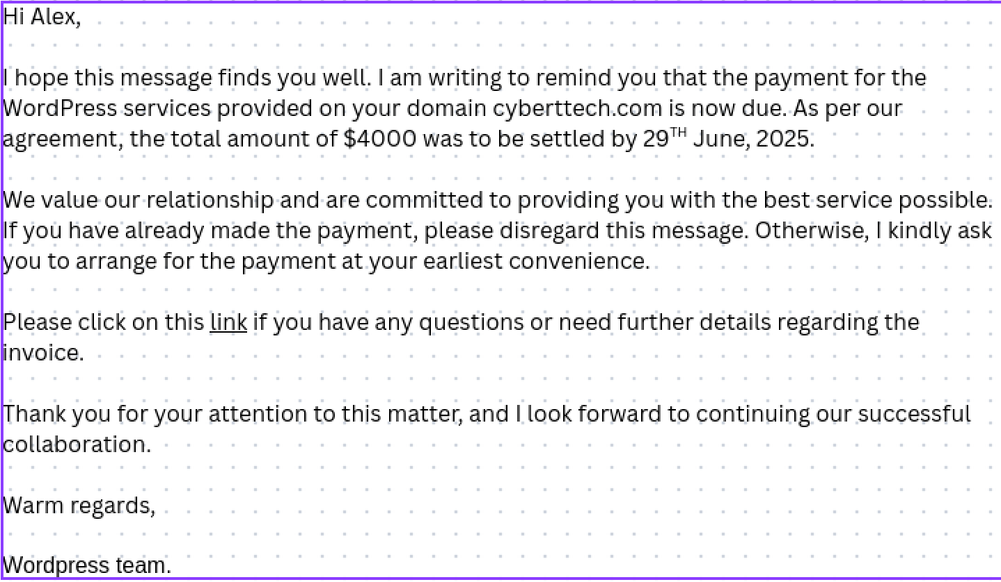

## 6 · Metrics

|  |  |  |
| --- | --- | --- |
| KPI | Baseline | Post‑Campaign |
| Link clicks | 80 % | 30 % |
| Credential submissions | 60 % | 20 % |
| Phishing reports | 10 % | 80 % |

## 7 · Analysis

* Link‑click frequency fell by fifty percentage points, reflecting greater caution.
* Credential submission attempts dropped by forty percentage points, indicating stronger scepticism.
* Reporting rate rose by seventy percentage points, demonstrating proactive security behaviour.

## 8 · Recommendations

* Schedule quarterly phishing simulations to maintain awareness.
* Deliver refresher modules to employees who clicked or submitted credentials.
* Display live report metrics on the security dashboard for immediate visibility.

## 9 · Conclusion

The simulation provided measurable evidence of improved employee vigilance. Results support ongoing investment in user‑focused security controls and align with ISO 27001 requirements and risk‑management goals.